Design a complete Coffee shop website using
HTML and CSS

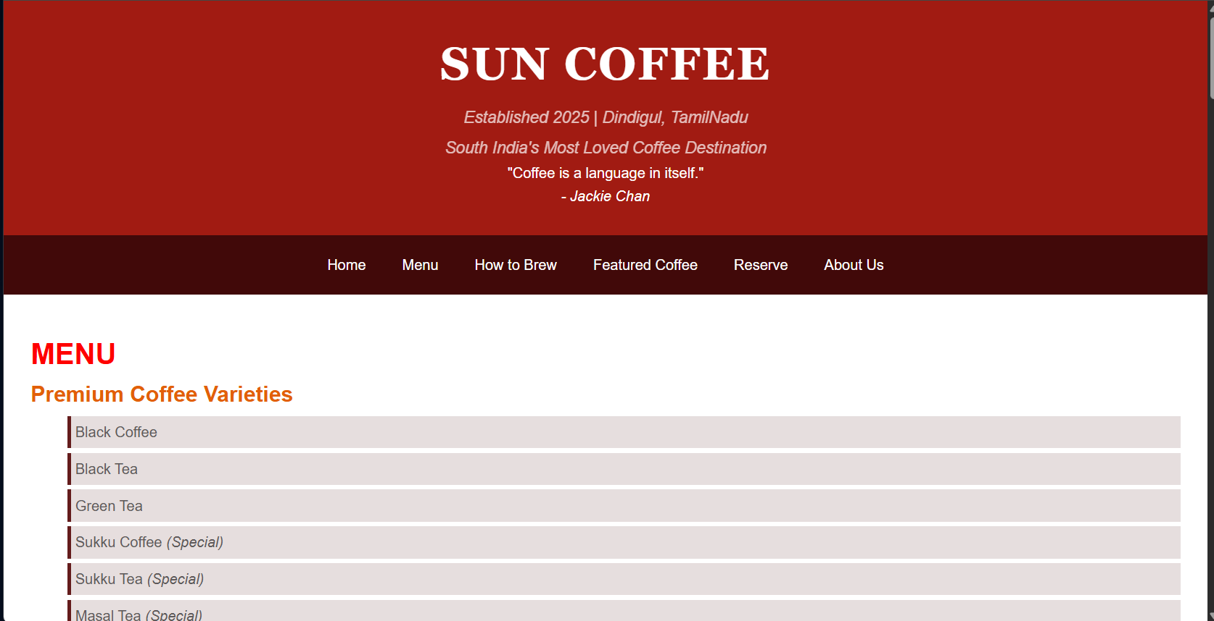
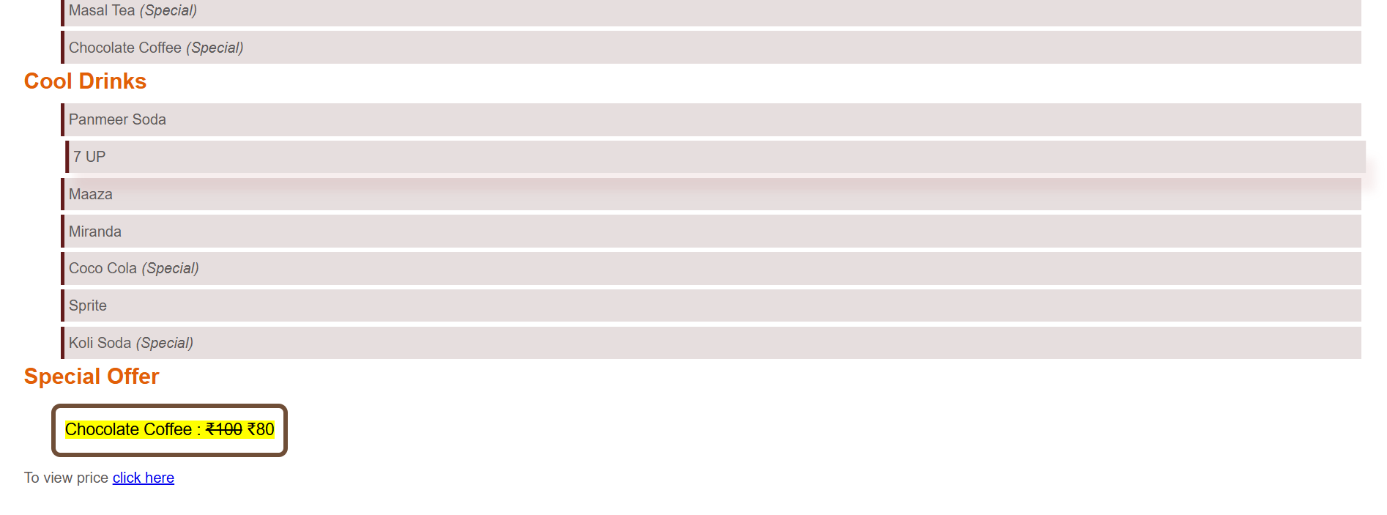
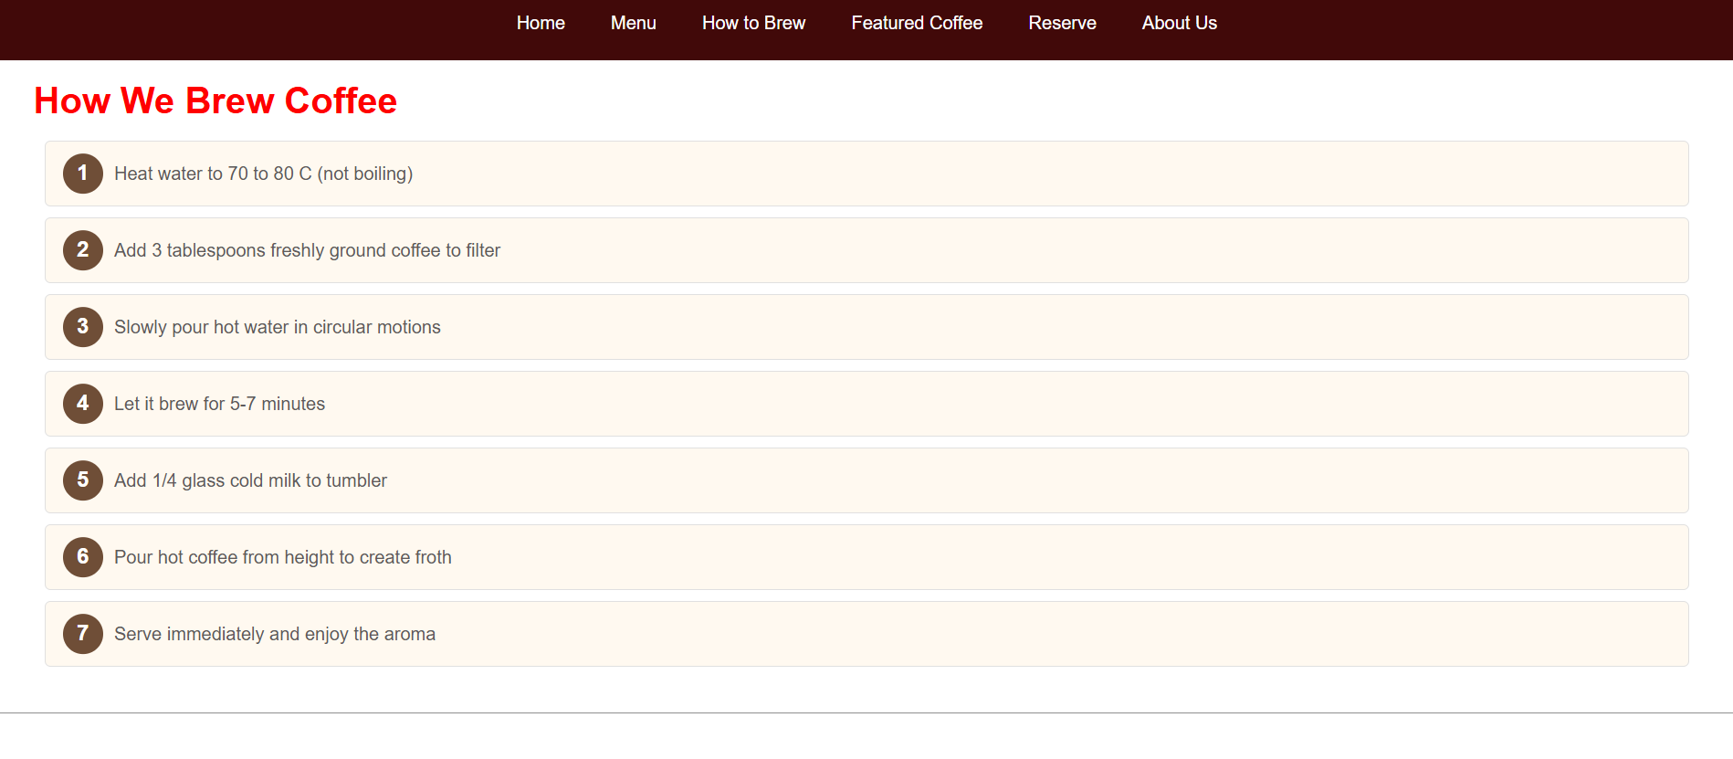
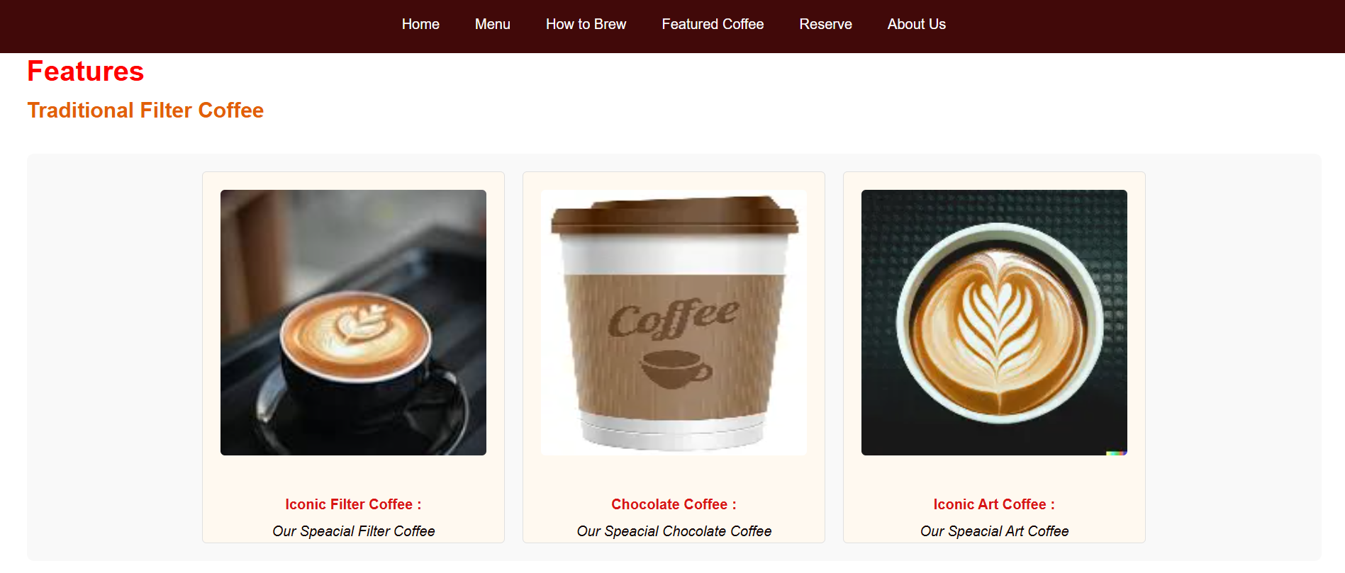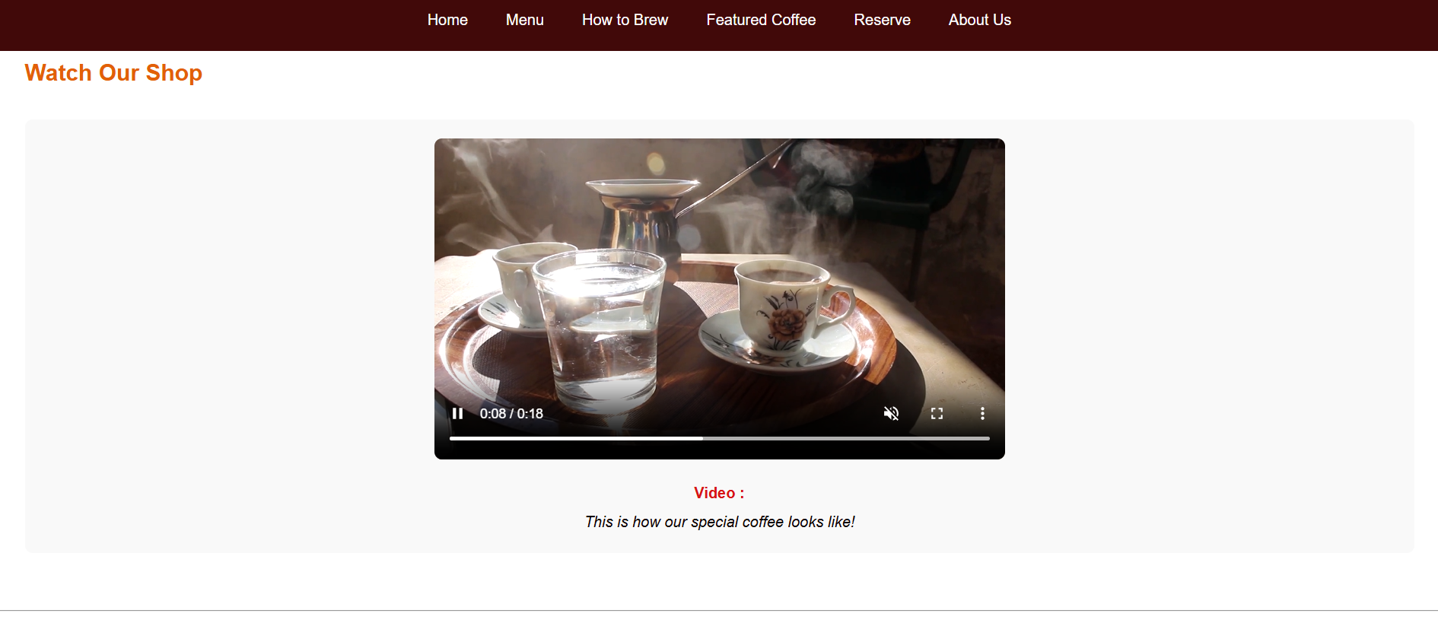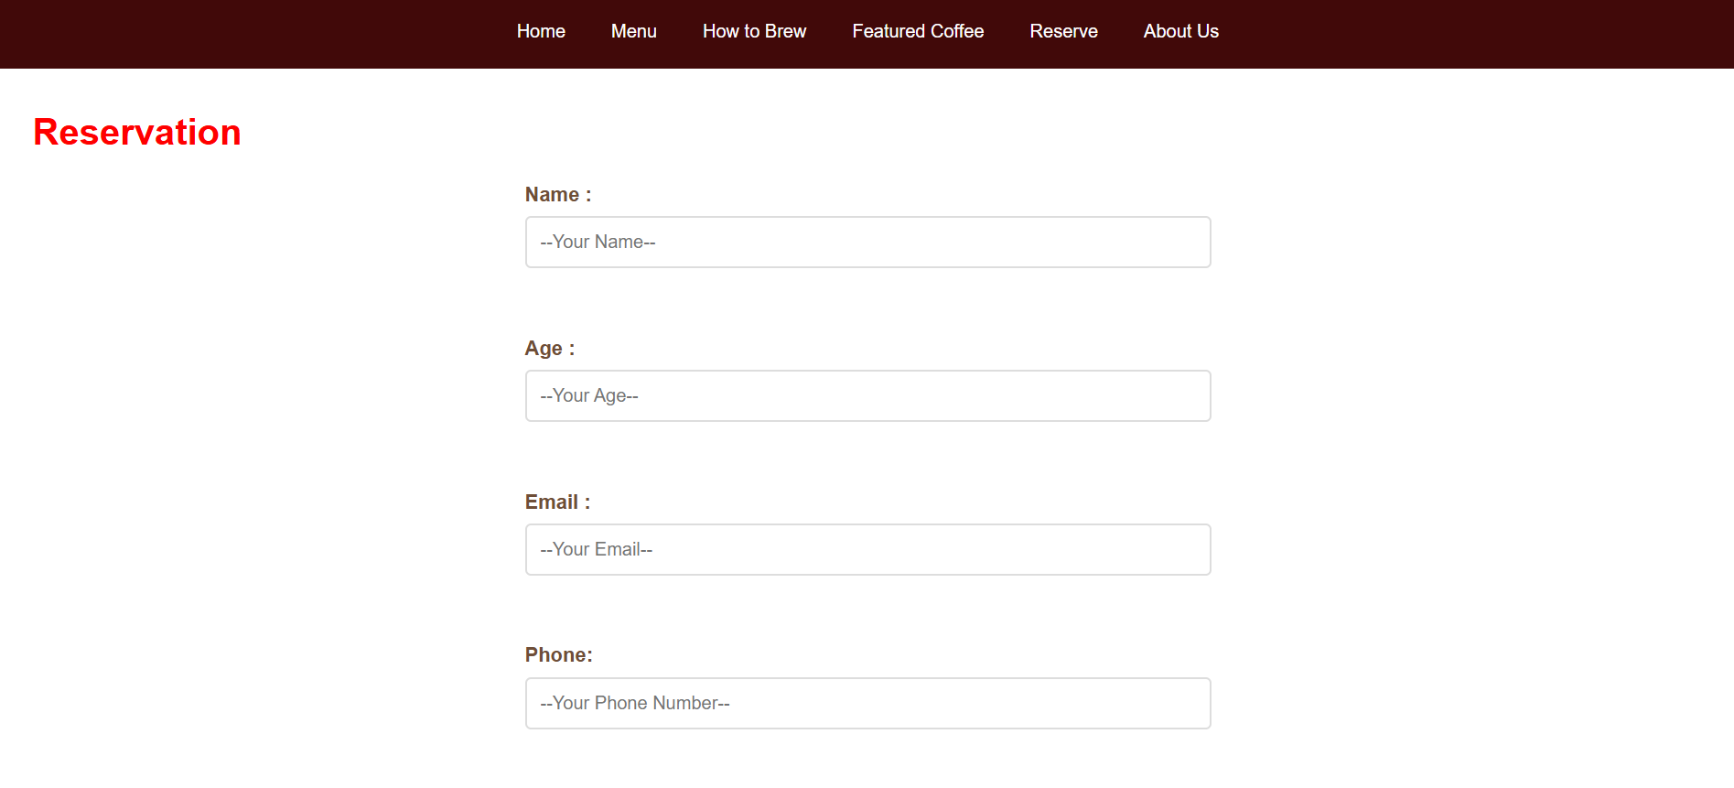
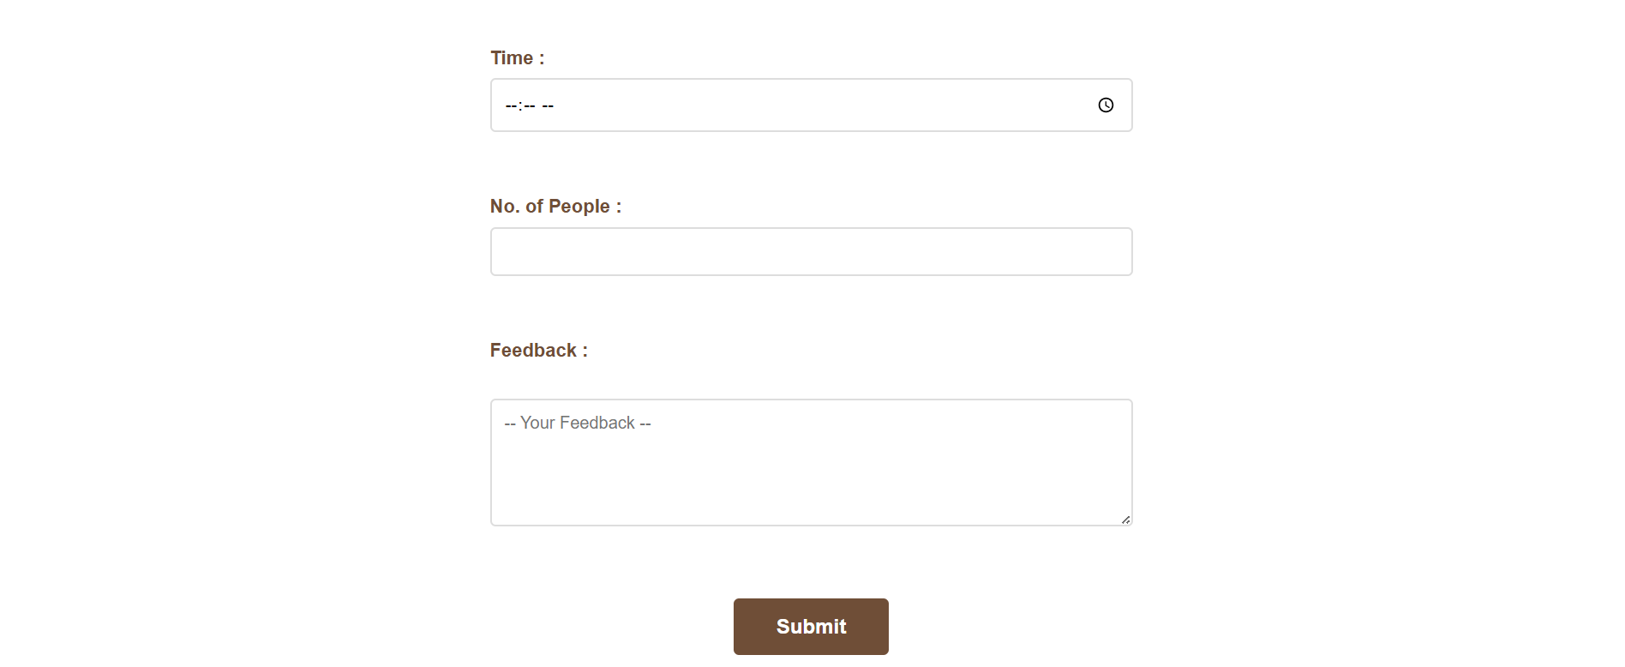


HTML :
<!DOCTYPE html>
<htmL lang = "en">
<head>
<title>Sun Coffee</title>
<meta charset = "UTF-8">
<meta name = "viewport" content="width=device-width" initial-scale = "1.0">
<meta name = "author" content = "Arumparithi B">
<meta name="description" content = "Reg no. : 2024503542 | CT Dept">
<meta name = "keywords" content = "Coffee,Sun Coffee">
<link rel="stylesheet" href="SunCoffee.css">
</head>
<body>
<header id = "home">
<h1>Sun Coffee</h1>
<p>Established 2025 | Dindigul, TamilNadu</p>
<p>South India's Most Loved Coffee Destination</p>
<blockquote>
"Coffee is a language in itself."<br>
<cite>- Jackie Chan</cite>
</blockquote>
</header>
<nav>
<ul>
<li> <a href="#home">Home</a></li>
<li> <a href="#menu">Menu</a></li>
<li> <a href="#brew">How to Brew</a></li>
<li> <a href="#fe">Featured Coffee</a></li>
<li> <a href="#res">Reserve</a></li>
<li> <a href="#about">About Us</a></li>
</ul>
</nav>
<main>
<section id = "menu">
<h2>MENU</h2>
<h3>Premium Coffee Varieties</h3>
<ul>
<li> Black Coffee</li>
<li> Black Tea</li>
<li> Green Tea</li>
<li> Sukku Coffee <i>(Special)</i></li>
<li> Sukku Tea <i>(Special)</i></li>
<li> Masal Tea <i>(Special)</i></li>
<li> Chocolate Coffee <i>(Special)</i></li>
</ul>
<h3>Cool Drinks</h3>
<ul>
<li> Panmeer Soda</li>
<li> 7 UP</li>
<li> Maaza</li>
<li> Miranda </li>
<li> Coco Cola <i>(Special)</i></li>
<li> Sprite</li>
<li> Koli Soda <i>(Special)</i></li>
</ul>
<h3>Special Offer</h3>
<p id = "offer"><mark>Chocolate Coffee : <del>₹100</del> ₹80</mark></p>
<p>To view price <a href="price.html">click here</a></p>
</section>
<hr>
<section id = "brew">
<h2>How We Brew Coffee</h2>
<ol>
<li> Heat water to 70 to 80 C (not boiling)</li>
<li> Add 3 tablespoons freshly ground coffee to filter</li>
<li> Slowly pour hot water in circular motions</li>
<li> Let it brew for 5-7 minutes</li>
<li> Add 1/4 glass cold milk to tumbler</li>
<li> Pour hot coffee from height to create froth</li>
<li> Serve immediately and enjoy the aroma</li>
</ol>
</section>
<hr>
<section id = "fe">
<h2>Features </h2>
<h3>Traditional Filter Coffee</h3>
<figure id = "fig">
<ol>
<li><img src = "coffee.jfif" width = "300px" alt = "Filter Coffee Image">
<figcaption><strong>Iconic Filter Coffee : </strong>Our Speacial Filter Coffee</figcaption></li>
<li><img src = "coffee2.webp" width = "300px" alt = "Chocolate Image">
<figcaption><strong>Chocolate Coffee : </strong>Our Speacial Chocolate Coffee</figcaption></li>
<li><img src = "coffee3.webp" width = "300px" alt = "Art Coffee Image">
<figcaption><strong>Iconic Art Coffee : </strong>Our Speacial Art Coffee</figcaption></li>
</ol>
</figure>
<h3>Watch Our Shop</h3>
<figure>
<video width = "400px" controls muted autoplay loop>
<source src = "video.mp4" type = "video/mp4" alt = "Coffee Shop Video">
</video>
<figcaption><strong>Video : </strong>This is how our special coffee looks like!</figcaption>
</figure>
</section>
<hr>
<section id = "res">
<h2>Reservation</h2>
<form action="#" method = "POST">
<label for="name">Name :</label>
<input type="text" id = "name" name = "name" placeholder="--Your Name--" required>
<br><br>
<label for = "age"> Age : </label>
<input type="number" id="age" name="age" placeholder="--Your Age--">
<br><br>
<label for="email">Email :</label>
<input type="email" id = "email" name = "email" placeholder = "--Your Email--" required>
<br><br>
<label for = "ph">Phone:</label>
<input type="tel" id="ph" name="phone" placeholder = "--Your Phone Number--" required>
<br><br>
<label for="date">Date :</label>
<input type="date" id = "date" name = "date" required>
<br><br>
<label for = "time"> Time : </label>
<input type="time" id="time" name="time">
<br><br>
<label for="no">No. of People :</label>
<input type="number" id = "no" name = "People" min = "1" max = "20" required>
<br><br>
<label for="feedback">Feedback :</label><br>
<textarea name="feedback" id="feedback" rows = "5" cols="40" placeholder="-- Your Feedback --"></textarea>
<br><br>
<button type = "submit">Submit</button>
</form>
</section>
</main>
<hr>
<footer id = "about">
<h2>About Us</h2>
<p>&copy 2025 | Sun Coffee Shop | Best for Kaapi</p>
<address>
<h3>Visit us : </h3>
Arumparithi B,<br>
Sun Coffee Shop,<br>
Dindigul, TamilNadu,<br>
India - 624001<br>
<h3>Hours</h3>
<p>Monday - Saturday : 7:00 AM - 10:00 PM</p>
<p>Sunday : 8:00 AM - 11:00 PM</p>
<h3>Contact Us</h3>
<p>E-mail : <a href="mailto: arumparithib@gmail.com">arumparithib@gmail.com</a></p>
<p>Phone : <a href="tel:+917397158733">+91 7397158733</a></p>
</address>
<br>
<p>Follow Us :
<a href="https://www.instagram.com/parithi_sun_ap2">Instagram</a> |
<a href="https://m.facebook.com/profile.php?id=61578341097989">Facebook</a>
</p>
</footer>
</body>
</htmL>

CSS :
*{
margin : 0;
padding : 0;
box-sizing : border-box;
}
body{
font-family : Arial, Helvetica, sans-serif;
line-height : 1.6;
color : rgb(94, 90, 90);
background-color : black
}
header{
background-color : rgb(161, 27, 18);
color : white;
text-align : center;
padding : 30px;
}
header h1{
font-size : 50px;
font-family : Georgia, 'Times New Roman', Times, serif;
text-transform : uppercase;
letter-spacing : 2px;
}
header p{
font-size : 18px;
margin-top : 5px;
font-style : italic;
opacity: 0.7;
}
nav{
background-color :rgb(65, 9, 9);
position:sticky;
top:0;
z-index:100;
}
nav ul{
list-style : none;
display: flex;
justify-content: center;
}

nav ul li a{
display:block;
color:white;
text-decoration:none;
padding:20px;
}
nav ul li a:hover{
color : rgb(175, 168, 168);
}
section{
background-color : white;
padding : 30px;
/*border-radius : 5px;*/
}
section h2{
color : red;
padding-top : 10px;
font-size : 2em;
}
section h3{
font-size : 1.5em;
color :rgb(226, 95, 8)
}
section ul{
list-style : none;
}
section ul li {
background-color: rgb(230, 222, 222);
margin-left : 40px;
margin-top : 5px;
padding: 5px;
border-left: 4px solid rgb(100, 28, 28);
}
section ul li:hover {
transform: translateX(5px);
box-shadow: 10px 20px 10px rgba(175, 91, 91, 0.1);
}
#offer{
margin: 10px;
display: inline-block;
border-radius: 10px;
padding : 10px;
border: 5px solid #6F4E37;
margin-left : 30px;
font-size: large;
}
section ol {
counter-reset: step-counter;
list-style: none;
padding-left: 0;
}

section ol li {
counter-increment: step-counter;
margin: 10px;
padding: 15px 15px 15px 60px;
background-color: #fff9f0;
border-radius: 5px;
position: relative;
border: 1px solid #e0e0e0;
}

section ol li::before {
content: counter(step-counter);
position: absolute;
left: 15px;
top: 50%;
transform: translateY(-50%);
background-color: #6F4E37;
color: white;
width: 35px;
height: 35px;
border-radius: 50%;
display: flex;
align-items: center;
justify-content: center;
font-weight: bold;
font-size: 1.2em;
}
figure {
margin: 30px 0;
text-align: center;
background-color: #f9f9f9;
padding: 20px;
border-radius: 8px;
}
figure img {
margin : 20px;
height : 300px;
border-radius: 5px;
}

figcaption {
margin-top: 15px;
font-style: italic;
color: #110404;
line-height: 1.6;
}
figcaption strong {
color: #d81515;
font-style: normal;
display: block;
margin-bottom: 5px;
}
#fig ol {
display: flex;
justify-content: center;
gap: 20px;
list-style: none;
padding: 0;
margin: 0;
}
#fig ol li {
display: inline-block;
counter-increment: none;
margin: 0;
padding: 0;
}
#fig ol li::before {
display: none;
}
video { max-width: 100%;
height: auto;
width : 600px;
border-radius: 8px;
}
#res form {
max-width: 600px;
margin: 0 auto;
}
label {
display: block;
margin-top: 15px;
margin-bottom: 5px;
color: #6F4E37;
font-weight: 600;
font-size: 1.1em;
}
input[type="text"],
input[type="email"],
input[type="tel"],
input[type="date"],
input[type="time"],
input[type="number"],
textarea {
width: 100%;
padding: 12px;
margin-bottom: 15px;
border: 2px solid #ddd;
border-radius: 5px;
font-size: 1em;
font-family: inherit;
transition: border-color 0.3s ease, box-shadow 0.3s ease;
box-sizing: border-box;
}
input[type="text"]:focus,
input[type="email"]:focus,
input[type="tel"]:focus,
input[type="date"]:focus,
input[type="time"]:focus,
input[type="number"]:focus,
textarea:focus {
outline: none;
border-color: #6F4E37;
box-shadow: 0 0 0 3px rgba(111, 78, 55, 0.1);
}
textarea {
resize: vertical;
min-height: 100px;
}
button[type="submit"] {
background-color: #6F4E37;
color: white;
padding: 15px 40px;
border: none;
border-radius: 5px;
font-size: 1.2em;
font-weight: 600;
cursor: pointer;
margin-top: 20px;
display: block;
margin-left: auto;
margin-right: auto;
transition: all 0.3s ease;
}
button[type="submit"]:hover {
background-color: #9f5e36;
transform: translateY(-2px);
box-shadow: 0 6px 15px rgba(111, 78, 55, 0.3);
}
button[type="submit"]:active {
transform: translateY(0);
}
footer {
background-color: #333;
color: white;
text-align: center;
padding: 2rem;
margin-top: 40px;
}
footer a {
color: #f1c40f;
text-decoration: none;
}

